2/27/18

Mr. Glen C. Falk
1525 Whitlow Xing
Bishop, GA 30621

Dear Glen:

It is my pleasure to extend to you an offer to provide “project work” for CapVisor Associates, LLC.
As discussed, this offer is for a specific systems project, that of fixing and improving our “R” client reporting capabilities. We are willing to accept a suggested compensation within your stated range and specifically offer a starting hourly rate of $45/hour. Our favorable assessment of your work, and your continued interest in working with CapVisor, may combine to provide additional opportunities to work together going forward.

We hope to move toward a quick determination regarding this position and would like to have your response to our offer by March 2, 2018.

While you will report directly to me for the time being, I expect that you will be working with Susan Levy and Rachel Libowitz, initially to get R working on their computers, the first step in the project. An initial conversation with Raghu Ramachandran, the system designer and programmer, and with Eric Joseph to help provide relevant background information will probably precede your work with Rachel and Susan.

We’re very excited to work with you and hope you share our enthusiasm for the opportunities and challenges ahead.

Warm Regards,
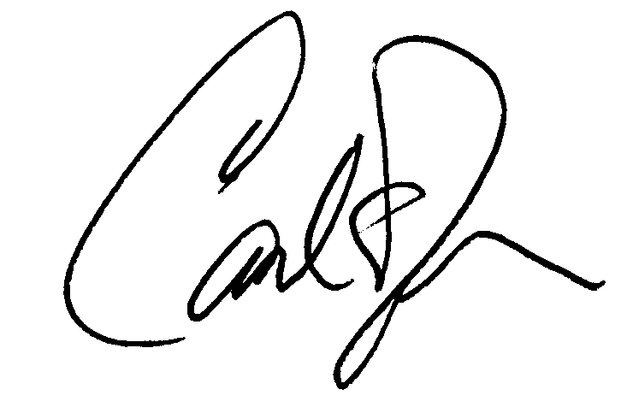
Carl E. Terzer
Principal
CapVisor Associates, LLC

Cc: Eric Joseph; Susan Levy

